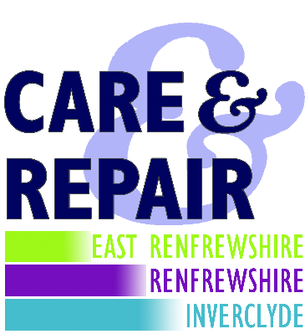
CARE & REPAIR
1st Floor
Bridgewater Shopping Centre
Erskine
PA8 7AA
www.carerepairrenfrewshire.org.uk

Tel: 0141 812 4111
Email: enquiries.carerepair@bridgewaterha.org.uk

Date: 23 June 2022

To whom I may concern

EAST RENFREWSHIRE GOOD CAUSES

I can confirm that East Renfrewshire Good Causes and Care & Repair have worked together for approximately 15 years, jointly supporting older and disabled people to enable them to remain comfortably and securely in their own homes. Care & Repair project manage disabled adaptations and carry out direct small repairs around the home for our clients, and East Renfrewshire Good Causes complement our services by funding or co-funding works which are unaffordable to clients and may otherwise not proceed.
Care & Repair work throughout three local authority areas – Renfrewshire, East Renfrewshire and Inverclyde and East Renfrewshire Good Causes provide assistance to our clients in all areas.
Yours faithfully

Project Manager

